|  |
| --- |
| IFMR RURAL FINANCE |
| Credit Committee Review |
|  |
| **IFMR Rural Finance** |
| **10/28/2016** |

|  |
| --- |
|  |

Contents

Process Diagram 3

1. Stage definition 4

2. Stage-role access 4

3. Credit Committee review Queue 4

3.1 UI specification 4

3.2 Screenshot 5

3.3 Functional requirements 6

3.4 Upload 6

3.5 Download 6

3.6 Reports 6

4. Capturing data 7

4.1 UI requirements 7

4.2 Screenshots 30

4.3 Functional requirements 65

4.4 Uploads 65

4.5 Downloads 65

4.6 Reports 65

5. Risk Score 3 65

5.1 UI specification 65

5.2 Screenshot 65

5.3 Functional requirements 65

5.4 Upload 65

5.5 Download 65

5.6 Reports 65

# Process Diagram



# Stage definition

|  |  |
| --- | --- |
| **Stage** | **Description** |
| Credit Committee Review Queue | The Credit committee member selects a profile from the pending for credit committee review queue (i.e. completed field appraisal review) |
| Credit Committee Remarks | The Credit committee reviews Application and give their remarks |
| Decision | The credit committee can Accept, Reject or send back the application |

# Stage-role access

|  |  |
| --- | --- |
| **Stage** | **Applicable Role** |
| Credit Committee Review Queue | Credit committee member |
| Credit Committee Remarks | Credit committee member |
| Decision | Credit committee |

# Credit Committee review Queue

## UI specification

|  |  |  |  |  |
| --- | --- | --- | --- | --- |
| **Field name** | **Section** | **Data Type** | **Attribute** | **Population logic** |
| S. No. | Field Appraisal Review Queue | Numeric |  |  |
| Applicant Name | Field Appraisal Review Queue | Text | Sort/search | From field appraisal review stage |
| Business Name | Field Appraisal Review Queue | Alphanumeric | Sort/search | From field appraisal review stage |
| URN No | Field Appraisal Review Queue | Alphanumeric | Sort/search | From field appraisal review stage |
| Area | Field Appraisal Review Queue | Text | Sort/search | From field appraisal review stage |
| City/Village/ Town | Field Appraisal Review Queue | Text | Sort/search | From field appraisal review stage |
| Pincode | Field Appraisal Review Queue | Numeric |  | From field appraisal review stage |

## Screenshot

* + 1. Search Page

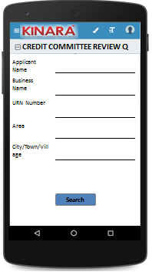

* + 1. Field Appraisal Review Queue

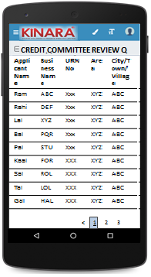

## Functional requirements

**Credit committee member** logs in

* The CC member opens the process dash board, and clicks on Credit committee Review queue
* If the CC member performs a search without selecting any parameter, then all cases with status ‘Pending for Field Appraisal Review’ to be displayed in a tabular format.
* If the CC member searches with ‘Applicant name’, ‘Business name’ or ‘URN no’, then all matching records that are ‘Pending for Credit committee Review’ (including existing customers) to be displayed in a tabular format.
* The CC member can **search and sort** the profiles based on the following parameters: URN no, Applicant Name, Business Name, Area, City/Village/Town.
* The CC member then selects a profile from the field appraisal review queue. The queue table should have applicant name, business name, URN No, Area, City/Town/Village as column names.
* All the columns will have **sorting** facility.

## Upload

-NA-

## Download

-NA-

## Reports

-NA-

# Capturing data

## UI requirements

|  |  |  |  |  |  |  |  |  |
| --- | --- | --- | --- | --- | --- | --- | --- | --- |
| **Entity** | **Tab** | **Sub tab** | **Section** | **Fields** | **Field Value** | **Mandatory** | **Conditional Mandatory** | **Remarks** |
| **APPLICANT** | **KYC Details** |  |  | Aadhar No | Numeric | Yes |  | Auto -populate from Field Appraisal Review |
| Document Capture | Upload | Yes |  | Auto -populate from Field Appraisal Review |
| Pan Number | Alpha numeric | Yes |  | Auto -populate from Field Appraisal Review |
| Document Capture | Upload | Yes |  | Auto -populate from Field Appraisal Review |
| ID Type | Dropdown |  |  | Auto -populate from Field Appraisal Review |
| ID No | Alpha numeric |  | Yes | Auto -populate from Field Appraisal Review |
| Valid Up to | Date |  |  | Auto -populate from Field Appraisal Review |
| Document Capture |  |  | Yes | Auto -populate from Field Appraisal Review |
| **Applicant Details** |  |  | Title* | Text | Yes |  | Auto -populate from Field Appraisal Review |
| Name* | Text | Yes |  | Auto -populate from Field Appraisal Review |
| Gender* | Text | Yes |  | Auto -populate from Field Appraisal Review |
| Date Of birth* | Text | Yes |  | Auto -populate from Field Appraisal Review |
| Age | Text |  |  | Auto -populate from Field Appraisal Review |
| Father's Name* | Text | Yes |  | Auto -populate from Field Appraisal Review |
| Educational Level* | Dropdown | Yes |  | Auto -populate from Field Appraisal Review |
| Religion* | Dropdown | Yes |  | Auto -populate from Field Appraisal Review |
| Mobile No* | Numeric | Yes |  | Auto -populate from Field Appraisal Review |
| Alternative Mobile No. | Numeric |  |  | Auto -populate from Field Appraisal Review |
| Whatsapp Mobile No. | Numeric |  |  | Auto -populate from Field Appraisal Review |
| Email ID | Alphanumeric,  special characters |  |  | Auto -populate from Field Appraisal Review |
| Preferred language of communication* | Dropdown | Yes |  | Auto -populate from Field Appraisal Review |
| Mother's Name | Text |  |  | Auto -populate from Field Appraisal Review |
| Marital Status | Dropdown | Yes |  | Auto -populate from Field Appraisal Review |
| Auto -populate from Field Appraisal Review |
| Spouse Name | Text |  |  | Auto -populate from Field Appraisal Review |
| Relationship with Business | Dropdown | Yes |  | Auto -populate from Field Appraisal Review |
| Business Involvement* | Dropdown | Yes |  | Auto -populate from Field Appraisal Review |
| Have you ever been a proprietor or partner of any other company | Radio Buttons |  |  | Auto -populate from Field Appraisal Review |
| If yes, did the business close? | Radio Buttons |  |  | Auto -populate from Field Appraisal Review |
| Month/Year (of business closure) | Date |  |  | Auto -populate from Field Appraisal Review |
| **Address Details** |  |  | Type Of Address | Dropdown | Yes |  | Auto -populate from Field Appraisal Review |
| Care of | Text |  |  | Auto -populate from Field Appraisal Review |
| Building* | Alphanumeric, special characters | Yes |  | Auto -populate from Field Appraisal Review |
| Street | Alphanumeric, special characters |  |  | Auto -populate from Field Appraisal Review |
| Landmark | Alphanumeric, special characters |  |  | Auto -populate from Field Appraisal Review |
| Locality | Alphanumeric, special characters |  |  | Auto -populate from Field Appraisal Review |
| Village/Town/City* | Text | Yes |  | Auto -populate from Field Appraisal Review |
| District* | Text | Yes |  | Auto -populate from Field Appraisal Review |
| State* | Text | Yes |  | Auto -populate from Field Appraisal Review |
| Pincode* | Numeric | Yes |  | Auto -populate from Field Appraisal Review |
| Country* | Text | Yes |  | Auto -populate from Field Appraisal Review |
| Location | GPS coordinates | Yes |  | Auto -populate from Field Appraisal Review |
| Is the Communication Address same as the Aadhar Card address? | Radio Buttons | Yes |  | Auto -populate from Field Appraisal Review |
| Line 1 | Alpha numeric |  | Yes | Auto -populate from Field Appraisal Review |
| Line 2 | Alpha numeric |  |  | Auto -populate from Field Appraisal Review |
| Area | Alpha numeric |  |  | Auto -populate from Field Appraisal Review |
| Land Mark | Alpha numeric |  | Yes | Auto -populate from Field Appraisal Review |
| Pincode | Numeric |  | Yes | Auto -populate from Field Appraisal Review |
| State | Text |  | Yes | Auto -populate from Field Appraisal Review |
| District | Text |  | Yes | Auto -populate from Field Appraisal Review |
| City/Town/Village | Text |  | Yes | Auto -populate from Field Appraisal Review |
| Landline Number | Numeric |  |  | Auto -populate from Field Appraisal Review |
| Ownership | Dropdown | Yes |  | Auto -populate from Field Appraisal Review |
| How many years are you living in present Area? | Dropdown | Yes |  | Auto -populate from Field Appraisal Review |
| How many years are you living in current Address? | Dropdown | Yes |  | Auto -populate from Field Appraisal Review |
| Is the Communication Address same as Permanent Address? | Radio Buttons | Yes |  | Auto -populate from Field Appraisal Review |
| **Family Member Details** |  |  | Name | Text |  |  | Auto -populate from Field Appraisal Review |
| Relationship with applicant | Dropdown |  |  | Auto -populate from Field Appraisal Review |
| Profession | Dropdown |  |  | Auto -populate from Field Appraisal Review |
| Salary | Numeric |  |  | Auto -populate from Field Appraisal Review |
| Education fee (annual) | Numeric |  |  | Auto -populate from Field Appraisal Review |
| Is a Co-applicant? | Radio Buttons |  |  | Auto -populate from Field Appraisal Review |
| **Household Financials** |  |  | Other Income Source | Dropdown |  |  | Auto -populate from Field Appraisal Review |
| Amount | Numeric |  |  | Auto -populate from Field Appraisal Review |
| Expense Type | Dropdown |  |  | Auto -populate from Field Appraisal Review |
| Amount | Numeric |  |  | Auto -populate from Field Appraisal Review |
| Monthly Education Expenses | Auto Calculated |  |  | Auto -populate from Field Appraisal Review |
| Family Exp. Based on Education expense | Auto Calculated |  |  | Auto -populate from Field Appraisal Review |
| Asset Type | Dropdown |  |  | Auto -populate from Field Appraisal Review |
| Vehicle make & model | Alphanumeric |  | Yes | Auto -populate from Field Appraisal Review |
| Registered Owner | Alpha |  | Yes | Auto -populate from Field Appraisal Review |
| Value of the asset | Numeric |  | Yes | Auto -populate from Field Appraisal Review |
| **Liabilities** |  |  | Debt Source | Dropdown |  |  | Auto -populate from Field Appraisal Review |
| Creditor's Name | Alphanumeric |  |  | Auto -populate from Field Appraisal Review |
| Loan Amount | Numeric |  |  | Auto -populate from Field Appraisal Review |
| Loan Outstanding | Numeric |  |  | Auto -populate from Field Appraisal Review |
| Loan term | Alphanumeric |  |  | Auto -populate from Field Appraisal Review |
| Monthly Instalment | Numeric |  |  | Auto -populate from Field Appraisal Review |
| No. of instalment Paid | Numeric |  |  | Auto -populate from Field Appraisal Review |
| Purpose | Dropdown |  |  | Auto -populate from Field Appraisal Review |
| **Bank Statement Details** |  |  | Bank Name | Alphanumeric | Yes |  | Auto -populate from Field Appraisal Review |
| Branch Name | Text |  |  | Auto -populate from Field Appraisal Review |
| IFSC Code | Numeric |  |  | Auto -populate from Field Appraisal Review |
| A/C name | Alphanumeric | Yes |  | Auto -populate from Field Appraisal Review |
| A/C type | Text | Yes |  | Auto -populate from Field Appraisal Review |
| A/C no | Numeric | Yes |  | Auto -populate from Field Appraisal Review |
| Banking since | Date |  |  | Auto -populate from Field Appraisal Review |
| Net banking available | Radio Buttons | Yes |  | Auto -populate from Field Appraisal Review |
| Sanctioned Amount | Numeric |  | Yes | Auto -populate from Field Appraisal Review |
| Start Month | Date | Yes |  | Auto -populate from Field Appraisal Review |
| Total Deposits* | Numeric | Yes |  | Auto -populate from Field Appraisal Review |
| Total Withdrawals* | Numeric | Yes |  | Auto -populate from Field Appraisal Review |
| Balance as on 15th* | Numeric | Yes |  | Auto -populate from Field Appraisal Review |
| No of cheques bounced* | Numeric | Yes |  | Auto -populate from Field Appraisal Review |
| No of EMI cheques bounced* | Numeric | Yes |  | Auto -populate from Field Appraisal Review |
| **References** |  |  | Reference Type | Dropdown | Yes |  | Auto -populate from Field Appraisal Review |
| Full Name | Alphanumeric |  |  | Auto -populate from Field Appraisal Review |
| Mobile No | Numeric |  |  | Auto -populate from Field Appraisal Review |
| Occupation | Dropdown |  |  | Auto -populate from Field Appraisal Review |
| Self-reported Income | Numeric |  |  | Auto -populate from Field Appraisal Review |
| **Proxy Indicators** |  |  | Proper & Matching Signboard | Radio Buttons | Yes |  | Auto -populate from Field Appraisal Review |
| Bribe Offered | Radio Buttons | Yes |  | Auto -populate from Field Appraisal Review |
| Shop/Shed Organized | Radio Buttons | Yes |  | Auto -populate from Field Appraisal Review |
| In Industrial Area | Radio Buttons | Yes |  | Auto -populate from Field Appraisal Review |
| Customer Attitude to Kinara | Radio Buttons | Yes |  | Auto -populate from Field Appraisal Review |
| Book-keeping Quality | Radio Buttons | Yes |  | Auto -populate from Field Appraisal Review |
| Challenging cheque bounce/fee charge/policies | Radio Buttons | Yes |  | Auto -populate from Field Appraisal Review |
| All Machines operational? | Radio Buttons | Yes |  | Auto -populate from Field Appraisal Review |
| Employee Satisfaction | Radio Buttons | Yes |  | Auto -populate from Field Appraisal Review |
| Political/Police Connections | Radio Buttons | Yes |  | Auto -populate from Field Appraisal Review |
| Multiple Products (more than 3) | Radio Buttons | Yes |  | Auto -populate from Field Appraisal Review |
| Multiple Buyers (more than 3) | Radio Buttons | Yes |  | Auto -populate from Field Appraisal Review |
| Seasonal Business | Radio Buttons | Yes |  | Auto -populate from Field Appraisal Review |
| Income Stability | Radio Buttons | Yes |  | Auto -populate from Field Appraisal Review |
| Utilization of business premises | Radio Buttons | Yes |  | Auto -populate from Field Appraisal Review |
| Approach for the business premises | Radio Buttons | Yes |  | Auto -populate from Field Appraisal Review |
| Safety measures for employees | Radio Buttons | Yes |  | Auto -populate from Field Appraisal Review |
| Child labourers | Radio Buttons | Yes |  | Auto -populate from Field Appraisal Review |
| Is the business in effecting environment? | Radio Buttons | Yes |  | Auto -populate from Field Appraisal Review |
| Stock/ Material Management | Radio Buttons | Yes |  | Auto -populate from Field Appraisal Review |
| **CO-APPLICANT** | **KYC Details** |  |  | Aadhar No | Numeric | Yes |  | Auto -populate from Field Appraisal Review |
| Document Capture | Upload | Yes |  | Auto -populate from Field Appraisal Review |
| Pan Number | Alpha numeric | Yes |  | Auto -populate from Field Appraisal Review |
| Document Capture | Upload | Yes |  | Auto -populate from Field Appraisal Review |
| ID Type | Dropdown |  |  | Auto -populate from Field Appraisal Review |
| ID No | Alpha numeric |  | Yes | Auto -populate from Field Appraisal Review |
| Valid Up to | Date |  | Yes | Auto -populate from Field Appraisal Review |
| Document Capture | Upload |  | Yes | Auto -populate from Field Appraisal Review |
| **Co-Applicant Details** |  |  | Title* | Text | Yes |  | Auto -populate from Field Appraisal Review |
| Name* | Text | Yes |  | Auto -populate from Field Appraisal Review |
| Gender* | Text | Yes |  | Auto -populate from Field Appraisal Review |
| Date Of birth* | Date | Yes |  | Auto -populate from Field Appraisal Review |
| Age | Numeric |  |  | Auto -populate from Field Appraisal Review |
| Auto -populate from Field Appraisal Review |
| Father's Name* | Text | Yes |  | Auto -populate from Field Appraisal Review |
| Educational Level* | Dropdown | Yes |  | Auto -populate from Field Appraisal Review |
| Religion* | Dropdown | Yes |  | Auto -populate from Field Appraisal Review |
| Mobile No* | Numeric | Yes |  | Auto -populate from Field Appraisal Review |
| Alternative Mobile No. | Numeric |  |  | Auto -populate from Field Appraisal Review |
| Whatsapp Mobile No. | Numeric |  |  | Auto -populate from Field Appraisal Review |
| Email ID | Alphanumeric, special characters |  |  | Auto -populate from Field Appraisal Review |
| Preferred language of communication* | Dropdown | Yes |  | Auto -populate from Field Appraisal Review |
| Auto -populate from Field Appraisal Review |
| Mothers Name | Text |  |  | Auto -populate from Field Appraisal Review |
| Marital Status | Dropdown | Yes |  | Auto -populate from Field Appraisal Review |
| Spouse Name | Text |  | Yes | Auto -populate from Field Appraisal Review |
| Relationship with Applicant | Text | Yes |  | Auto -populate from Field Appraisal Review |
| Relationship with Business | Dropdown | Yes |  | Auto -populate from Field Appraisal Review |
| Business Involvement* | Dropdown | Yes |  | Auto -populate from Field Appraisal Review |
| Have you ever been a proprietor or partner of any other company | Radio Buttons |  |  | Auto -populate from Field Appraisal Review |
| If yes, did the business close? | Radio Buttons |  |  | Auto -populate from Field Appraisal Review |
| Month/Year (of business closure) | Date |  |  | Auto -populate from Field Appraisal Review |
| **Address Details** |  |  | Type Of Address | Dropdown | Yes |  | Auto -populate from Field Appraisal Review |
| Care of | Text |  |  | Auto -populate from Field Appraisal Review |
| Building* | Alphanumeric, special characters | Yes |  | Auto -populate from Field Appraisal Review |
| Street | Alphanumeric, special characters |  |  | Auto -populate from Field Appraisal Review |
| Landmark | Alphanumeric, special characters |  |  | Auto -populate from Field Appraisal Review |
| Locality | Alphanumeric, special characters |  |  | Auto -populate from Field Appraisal Review |
| Village/Town/City* | Text | Yes |  | Auto -populate from Field Appraisal Review |
| District* | Text | Yes |  | Auto -populate from Field Appraisal Review |
| State* | Text | Yes |  | Auto -populate from Field Appraisal Review |
| Pincode* | Numeric | Yes |  | Auto -populate from Field Appraisal Review |
| Country* | Text | Yes |  | Auto -populate from Field Appraisal Review |
| Location | GPS coordinates |  |  | Auto -populate from Field Appraisal Review |
| Is the Communication Address same as the Aadhar Card address? | Radio Buttons | Yes |  | Auto -populate from Field Appraisal Review |
| Line 1 | Alpha numeric |  | Yes | Auto -populate from Field Appraisal Review |
| Line 2 | Alpha numeric |  |  | Auto -populate from Field Appraisal Review |
| Area | Alpha numeric |  |  | Auto -populate from Field Appraisal Review |
| Land Mark | Alpha numeric |  | Yes | Auto -populate from Field Appraisal Review |
| Pincode | Numeric |  | yes | Auto -populate from Field Appraisal Review |
| State | Auto populated |  | Yes | Auto -populate from Field Appraisal Review |
| District | Auto populated |  | Yes | Auto -populate from Field Appraisal Review |
| City/Town/Village | Auto populated |  | Yes | Auto -populate from Field Appraisal Review |
| Location (GPS) | GPS coordinates |  |  | Auto -populate from Field Appraisal Review |
| Landline Number | Numeric |  |  | Auto -populate from Field Appraisal Review |
| Ownership | Dropdown | Yes |  | Auto -populate from Field Appraisal Review |
| How many years are you living in present Area? | Dropdown | Yes |  | Auto -populate from Field Appraisal Review |
| How many years are you living in current Address? | Dropdown | Yes |  | Auto -populate from Field Appraisal Review |
| Is the Communication Address same as Permanent Address? | Radio Buttons | Yes |  | Auto -populate from Field Appraisal Review |
| **Family Member Details** |  |  | Name | Text |  |  | Auto -populate from Field Appraisal Review |
| Relationship with co-applicant | Text |  |  | Auto -populate from Field Appraisal Review |
| Profession | Text |  |  | Auto -populate from Field Appraisal Review |
| Salary | Numeric |  |  | Auto -populate from Field Appraisal Review |
| Education fee (annual) | Numeric |  |  | Auto -populate from Field Appraisal Review |
| **Household Financials** |  |  | Other Income Source | Dropdown |  |  | Auto -populate from Field Appraisal Review |
| Amount | Numeric |  |  | Auto -populate from Field Appraisal Review |
| Expense Type | Dropdown |  |  | Auto -populate from Field Appraisal Review |
| Amount | Numeric |  |  | Auto -populate from Field Appraisal Review |
| Monthly Education Expenses | Auto Calculated |  |  | Auto -populate from Field Appraisal Review |
| Family Exp. Based on Education expense | Auto Calculated |  |  | Auto -populate from Field Appraisal Review |
| Asset Type | Dropdown |  |  | Auto -populate from Field Appraisal Review |
| Vehicle make & model | Alphanumeric |  | Yes | Auto -populate from Field Appraisal Review |
| Registered Owner | Alpha |  | Yes | Auto -populate from Field Appraisal Review |
| Value of the asset | Numeric |  | Yes | Auto -populate from Field Appraisal Review |
| **Bank Statement Details** |  |  | Bank Name | Alphanumeric | Yes |  | Auto -populate from Field Appraisal Review |
| Branch Name | Text |  |  | Auto -populate from Field Appraisal Review |
| IFSC Code | Numeric |  |  | Auto -populate from Field Appraisal Review |
| A/C name | Alphanumeric | Yes |  | Auto -populate from Field Appraisal Review |
| A/C type | Text | Yes |  | Auto -populate from Field Appraisal Review |
| A/C no | Numeric | Yes |  | Auto -populate from Field Appraisal Review |
| Auto -populate from Field Appraisal Review |
| Banking since | Date |  |  | Auto -populate from Field Appraisal Review |
| Net banking available | Radio Buttons | Yes |  | Auto -populate from Field Appraisal Review |
| Sanctioned Amount | Numeric |  | Yes | Auto -populate from Field Appraisal Review |
| Start Month | Date | Yes |  | Auto -populate from Field Appraisal Review |
| Total Deposits* | Numeric | Yes |  | Auto -populate from Field Appraisal Review |
| Total Withdrawals* | Numeric | Yes |  | Auto -populate from Field Appraisal Review |
| Balance as on 15th* | Numeric | Yes |  | Auto -populate from Field Appraisal Review |
| No of cheques bounced* | Numeric | Yes |  | Auto -populate from Field Appraisal Review |
| No of EMI cheques bounced* | Numeric | Yes |  | Auto -populate from Field Appraisal Review |
| **GUARANTOR** | **KYC Details** |  |  | Aadhar No | Numeric | Yes |  | Auto -populate from Field Appraisal Review |
| Document Capture | Upload | Yes |  | Auto -populate from Field Appraisal Review |
| Pan Number | Alpha numeric | Yes |  | Auto -populate from Field Appraisal Review |
| Document Capture | Auto populate/Upload | Yes |  | Auto -populate from Field Appraisal Review |
| ID Type | Dropdown |  |  | Auto -populate from Field Appraisal Review |
| ID No | Alpha numeric |  | Yes | Auto -populate from Field Appraisal Review |
| Valid up to | Date |  | Yes | Auto -populate from Field Appraisal Review |
| Document Capture | Upload | Yes | Yes | Auto -populate from Field Appraisal Review |
| **Guarantor Details** |  |  | Title* | Text | Yes |  | Auto -populate from Field Appraisal Review |
| Name* | Text | Yes |  | Auto -populate from Field Appraisal Review |
| Gender* | Text | Yes |  | Auto -populate from Field Appraisal Review |
| Date Of birth* | Date | Yes |  | Auto -populate from Field Appraisal Review |
| Age | Numeric |  |  | Auto -populate from Field Appraisal Review |
| Father's Name* | Text | Yes |  | Auto -populate from Field Appraisal Review |
| Educational Level* | Dropdown | yes |  | Auto -populate from Field Appraisal Review |
| Religion* | Dropdown | Yes |  | Auto -populate from Field Appraisal Review |
| Mobile No* | Numeric | Yes |  | Auto -populate from Field Appraisal Review |
| Alternative Mobile No. | Numeric |  |  | Auto -populate from Field Appraisal Review |
| Whatsapp Mobile No. | Numeric |  |  | Auto -populate from Field Appraisal Review |
| Email ID | Alphanumeric, special characters |  |  | Auto -populate from Field Appraisal Review |
| Preferred language of communication* | Dropdown | Yes |  | Auto -populate from Field Appraisal Review |
| Mother's Name | Text |  |  | Auto -populate from Field Appraisal Review |
| Marital Status | Dropdown | Yes |  | Auto -populate from Field Appraisal Review |
| Spouse Name | Text |  | Yes | Auto -populate from Field Appraisal Review |
| Relationship with Applicant | Dropdown | Yes |  | Auto -populate from Field Appraisal Review |
| Business Involvement* | Dropdown | Yes |  | Auto -populate from Field Appraisal Review |
| Have you ever been a proprietor or partner of any other company | Radio Buttons |  |  | Auto -populate from Field Appraisal Review |
| If yes, did the business close? | Radio Buttons |  |  | Auto -populate from Field Appraisal Review |
| Month/Year (of business closure) | Date |  |  | Auto -populate from Field Appraisal Review |
| **Address Details** |  |  | Type Of Address | Dropdown | Yes |  | Auto -populate from Field Appraisal Review |
| Care of | Text |  |  | Auto -populate from Field Appraisal Review |
| Building* | Alphanumeric, special characters | Yes |  | Auto -populate from Field Appraisal Review |
| Street | Alphanumeric, special characters |  |  | Auto -populate from Field Appraisal Review |
| Landmark | Alphanumeric, special characters |  |  | Auto -populate from Field Appraisal Review |
| Locality | Alphanumeric, special characters |  |  | Auto -populate from Field Appraisal Review |
| Village/Town/City* | Text | Yes |  | Auto -populate from Field Appraisal Review |
| District* | Text | Yes |  | Auto -populate from Field Appraisal Review |
| State* | Text | Yes |  | Auto -populate from Field Appraisal Review |
| Pincode* | Numeric | Yes |  | Auto -populate from Field Appraisal Review |
| Country* | Text | Yes |  | Auto -populate from Field Appraisal Review |
| Is the Communication Address same as the Aadhar Card address? | Radio Buttons | Yes |  | Auto -populate from Field Appraisal Review |
| Line 1 | Alpha numeric |  | Yes | Auto -populate from Field Appraisal Review |
| Line 2 | Alpha numeric |  |  | Auto -populate from Field Appraisal Review |
| Area | Alpha numeric |  |  | Auto -populate from Field Appraisal Review |
| Land Mark | Alpha numeric |  | Yes | Auto -populate from Field Appraisal Review |
| Pincode | Numeric |  | Yes | Auto -populate from Field Appraisal Review |
| State | Auto populated |  | Yes | Auto -populate from Field Appraisal Review |
| District | Auto populated |  | Yes | Auto -populate from Field Appraisal Review |
| City/Town/ Village | Auto populated |  | Yes | Auto -populate from Field Appraisal Review |
| Location (GPS) | GPS coordinates |  |  | Auto -populate from Field Appraisal Review |
| Landline Number | Numeric |  |  | Auto -populate from Field Appraisal Review |
| Ownership | Dropdown | Yes |  | Auto -populate from Field Appraisal Review |
| How many years are you living in present Area? | Dropdown | Yes |  | Auto -populate from Field Appraisal Review |
| How many years are you living in current Address? | Dropdown | Yes |  | Auto -populate from Field Appraisal Review |
| Is the Communication Address same as Permanent Address? | Radio Buttons | Yes |  | Auto -populate from Field Appraisal Review |
| **BUSINESS** | **Business Detail** |  |  | Referred by | Dropdown | Yes |  | Auto -populate from Field Appraisal Review |
| Referred Name | Text |  | Yes (Based on the dropdown) | Auto -populate from Field Appraisal Review |
| Business Name | Text | Yes |  | Auto -populate from Field Appraisal Review |
| Business type | Dropdown | Yes |  | Auto -populate from Field Appraisal Review |
| Business Activity | Radio Buttons | Yes |  | Auto -populate from Field Appraisal Review |
| Business Sector | Text | Yes |  | Auto -populate from Field Appraisal Review |
| Business Sub sector | Text | Yes |  | Auto -populate from Field Appraisal Review |
| ITR available? | Radio Buttons |  |  | Auto -populate from Field Appraisal Review |
| Auto -populate from Field Appraisal Review |
| Business Operating since | Date |  |  | Auto -populate from Field Appraisal Review |
| Auto -populate from Field Appraisal Review |
| Is the Business Registered? | Radio Buttons | Yes |  | Auto -populate from Field Appraisal Review |
| Business Registration Type | Dropdown |  | Yes | Auto -populate from Field Appraisal Review |
| Business Registration Proof No | Alpha numeric |  | Yes | Auto -populate from Field Appraisal Review |
| Business Registration Date | Date |  | Yes | Auto -populate from Field Appraisal Review |
| Valid up to | Date |  | Yes | Auto -populate from Field Appraisal Review |
| Constitution | Dropdown |  |  | Auto -populate from Field Appraisal Review |
| If partnership, how many total partners | Dropdown |  | Yes | Auto -populate from Field Appraisal Review |
| Has anyone else been a partner of your present business | Radio Buttons |  |  | Auto -populate from Field Appraisal Review |
| If yes, when was that partnership dissolved? | Date |  | Dissolution Agreement required | Auto -populate from Field Appraisal Review |
| **Address Details** |  |  | Line 1 | Alpha numeric | Yes |  | Auto -populate from Field Appraisal Review |
| Line 2 | Alpha numeric |  |  | Auto -populate from Field Appraisal Review |
| Pin Code | Numeric | Yes |  | Auto -populate from Field Appraisal Review |
| Land Mark | Text | Yes |  | Auto -populate from Field Appraisal Review |
| State | Auto populated | Yes |  | Auto -populate from Field Appraisal Review |
| District | Auto populated | Yes |  | Auto -populate from Field Appraisal Review |
| City/Village | Auto populated | Yes |  | Auto -populate from Field Appraisal Review |
| Location (GPS) | GPS coordinates | Yes |  | Auto -populate from Field Appraisal Review |
| Landline Phone | Numeric | Yes |  | Auto -populate from Field Appraisal Review |
| Ownership | Dropdown | Yes |  | Auto -populate from Field Appraisal Review |
| How many years business in present Area? | Dropdown | Yes |  | Auto -populate from Field Appraisal Review |
| How many years business in current address? | Dropdown | Yes |  | Auto -populate from Field Appraisal Review |
| **Employee Detail** |  |  | No of Male Employees | Numeric |  |  | Auto -populate from Field Appraisal Review |
| No of Female Employees | Numeric |  |  | Auto -populate from Field Appraisal Review |
| Average Monthly Salary | Numeric |  |  | Auto -populate from Field Appraisal Review |
| **Buyer Detail** |  |  | Buyer Name | Alpha numeric |  | Yes | Auto -populate from Field Appraisal Review |
| Customer Since | Dropdown |  | Yes | Auto -populate from Field Appraisal Review |
| Sector | Dropdown |  | Yes | Auto -populate from Field Appraisal Review |
| Sub Sector | Dropdown |  | Yes | Auto -populate from Field Appraisal Review |
| Product | alpha numeric |  |  | Auto -populate from Field Appraisal Review |
| Payment terms (days) | numeric |  |  | Auto -populate from Field Appraisal Review |
| Payment date | Date |  |  | Auto -populate from Field Appraisal Review |
| Payment Frequency | Dropdown |  |  | Auto -populate from Field Appraisal Review |
| Receivables Outstanding / Customer Credit | numeric |  |  | Auto -populate from Field Appraisal Review |
| **Business Financials** | **Income** | Through Sales | Buyer Name | Dropdown |  |  | Auto -populate from Field Appraisal Review |
| Income type | Radio Buttons |  |  | Auto -populate from Field Appraisal Review |
| Amount | Numeric |  |  | Auto -populate from Field Appraisal Review |
| Date | Date |  |  | Auto -populate from Field Appraisal Review |
| Other Business Income | Income Source | Dropdown |  |  | Auto -populate from Field Appraisal Review |
| Amount | Numeric |  |  | Auto -populate from Field Appraisal Review |
| Date | Date |  |  | Auto -populate from Field Appraisal Review |
| **Expenses** | Raw material expense | Vendor Name | Alphanumeric |  | Yes | Auto -populate from Field Appraisal Review |
| Type | Radio Buttons |  |  | Auto -populate from Field Appraisal Review |
| Amount | Numeric |  |  | Auto -populate from Field Appraisal Review |
| Date | Date |  |  | Auto -populate from Field Appraisal Review |
| Salary and Wages | Owner's Salary | Numeric |  |  | Auto -populate from Field Appraisal Review |
| Co- Owner's Salary | Numeric |  |  | Auto -populate from Field Appraisal Review |
| Employee's Salary | Numeric |  |  | Auto -populate from Field Appraisal Review |
| Fixed Obligations | Payment of Debts | Numeric |  |  | Auto -populate from Field Appraisal Review |
| Savings/Committee/Chits | Numeric |  |  | Auto -populate from Field Appraisal Review |
| Insurance Premium amount | Numeric |  |  | Auto -populate from Field Appraisal Review |
| Other Expenses | Rent | Numeric |  |  | Auto -populate from Field Appraisal Review |
| Sub-Contractor Payment | Numeric |  |  | Auto -populate from Field Appraisal Review |
| Tools & Consumables | Numeric |  |  | Auto -populate from Field Appraisal Review |
| Electricity Charges | Numeric |  |  | Auto -populate from Field Appraisal Review |
| Transportation Costs | Numeric |  |  | Auto -populate from Field Appraisal Review |
| Repair and Maintenance | Numeric |  |  | Auto -populate from Field Appraisal Review |
| General Admin | Numeric |  |  | Auto -populate from Field Appraisal Review |
| **Assets** | Current Assets | Cash At Bank | Numeric |  |  | Auto -populate from Field Appraisal Review |
| Inventory | Raw Material | Numeric |  |  | Auto -populate from Field Appraisal Review |
| WIP | Numeric |  |  | Auto -populate from Field Appraisal Review |
| Finished Goods | Numeric |  |  | Auto -populate from Field Appraisal Review |
| Machinery | Machine Description | Alphanumeric |  | Yes | Auto -populate from Field Appraisal Review |
| Manufacturer Name | Alphanumeric |  |  | Auto -populate from Field Appraisal Review |
| Machine Type | Dropdown |  |  | Auto -populate from Field Appraisal Review |
| Machine Model | Alphanumeric |  |  | Auto -populate from Field Appraisal Review |
| Serial Number | Alphanumeric |  |  | Auto -populate from Field Appraisal Review |
| Purchase Price | Numeric |  |  | Auto -populate from Field Appraisal Review |
| Machine Purchased Year | Numeric |  |  | Auto -populate from Field Appraisal Review |
| Present Value | Numeric |  |  | Auto -populate from Field Appraisal Review |
| Is the Machine New? | Radio Buttons |  |  | Auto -populate from Field Appraisal Review |
| Funding Source | Dropdown |  |  | Auto -populate from Field Appraisal Review |
| Is the Machine Hypothecated? | Radio Buttons |  |  | Auto -populate from Field Appraisal Review |
| Machine Permanently fixed to building? | Radio Buttons |  |  | Auto -populate from Field Appraisal Review |
| Machine Bills | Upload |  | Yes | Auto -populate from Field Appraisal Review |
| Other Fixed assets | Asset Type | Dropdown |  |  | Auto -populate from Field Appraisal Review |
| Vehicle Make & Model (if asset type is vehicle) | Alphanumeric |  | Yes | Auto -populate from Field Appraisal Review |
| Value of Asset | Numeric |  |  | Auto -populate from Field Appraisal Review |
| **Company Liabilities** |  | Debt Source | Dropdown |  |  | Auto -populate from Field Appraisal Review |
| Creditor's Name | Alphanumeric |  |  | Auto -populate from Field Appraisal Review |
| Loan Amount | Numeric |  |  | Auto -populate from Field Appraisal Review |
| Loan Outstanding | Numeric |  |  | Auto -populate from Field Appraisal Review |
| Loan term | Alphanumeric |  |  | Auto -populate from Field Appraisal Review |
| Monthly Instalment | Numeric |  |  | Auto -populate from Field Appraisal Review |
| No. Of instalment Paid | Numeric |  |  | Auto -populate from Field Appraisal Review |
| Purpose | Dropdown |  |  | Auto -populate from Field Appraisal Review |
| Supplier's Name | Alphanumeric |  |  | Auto -populate from Field Appraisal Review |
| Type | Dropdown |  |  | Auto -populate from Field Appraisal Review |
| Payment terms (days) | Numeric |  |  | Auto -populate from Field Appraisal Review |
| Amount | Numeric |  |  | Auto -populate from Field Appraisal Review |
| **Financial Summary** |  | Sales | Numeric |  |  | Auto -populate from Field Appraisal Review |
| Purchases | Numeric |  |  | Auto -populate from Field Appraisal Review |
| Operating Expenses | Numeric |  |  | Auto -populate from Field Appraisal Review |
| Household Expenses | Numeric |  |  | Auto -populate from Field Appraisal Review |
| Fixed Obligations | Numeric |  |  | Auto -populate from Field Appraisal Review |
| Net Business Income | Numeric |  |  | Auto -populate from Field Appraisal Review |
| **Bank Statement Details** |  |  | Bank Name | Alphanumeric | Yes |  | Auto -populate from Field Appraisal Review |
| Branch Name | Text |  |  | Auto -populate from Field Appraisal Review |
| IFSC Code | Numeric |  |  | Auto -populate from Field Appraisal Review |
| A/C name | Alphanumeric | Yes |  | Auto -populate from Field Appraisal Review |
| A/C type | Text | Yes |  | Auto -populate from Field Appraisal Review |
| A/C no | Numeric | Yes |  | Auto -populate from Field Appraisal Review |
| Banking since | Date |  |  | Auto -populate from Field Appraisal Review |
| Net banking available | Radio Buttons | Yes |  | Auto -populate from Field Appraisal Review |
| Sanctioned Amount | Numeric |  | Yes | Auto -populate from Field Appraisal Review |
| Start Month | Date | Yes |  | Auto -populate from Field Appraisal Review |
| Total Deposits* | Numeric |  |  | Auto -populate from Field Appraisal Review |
| Total Withdrawals* | Numeric |  |  | Auto -populate from Field Appraisal Review |
| Balance as on 15th* | Numeric |  |  | Auto -populate from Field Appraisal Review |
| No of cheques bounced* | Numeric |  |  | Auto -populate from Field Appraisal Review |
| No of EMI cheques bounced* | Numeric |  |  | Auto -populate from Field Appraisal Review |
| **References** |  |  | Reference type | Dropdown | Yes |  | Auto -populate from Field Appraisal Review |
| Business Name | Alpha numeric |  |  | Auto -populate from Field Appraisal Review |
| Full Name of POC | Alpha numeric |  |  | Auto -populate from Field Appraisal Review |
| Mobile No | Numeric |  |  | Auto -populate from Field Appraisal Review |
| Business Sector | Dropdown |  |  | Auto -populate from Field Appraisal Review |
| Business sub sector | Dropdown |  |  | Auto -populate from Field Appraisal Review |
| Self-reported Income | Numeric |  |  | Auto -populate from Field Appraisal Review |
| **LOAN DETAILS** | **Loan Proposal** |  |  | Purpose | Dropdown | Yes |  | Auto -populate from Field Appraisal Review |
| Sub-purpose | Dropdown | Yes |  | Auto -populate from Field Appraisal Review |
| Do you have assets available for hypothecation | Radio Buttons |  |  | Auto -populate from Field Appraisal Review |
| If yes, estimated value of assets | Numeric |  | Yes | Auto -populate from Field Appraisal Review |
| Loan Amount | Numeric | Yes |  | Auto -populate from Field Appraisal Review |
| Term | Alpha numeric | Yes |  | Auto -populate from Field Appraisal Review |
| EMI Requested | Numeric | Yes |  | Auto -populate from Field Appraisal Review |
| EMI Payment Date Requested | Date |  |  | Auto -populate from Field Appraisal Review |
| Frequency | Dropdown | Yes |  | Auto -populate from Field Appraisal Review |
| Estimated date of Completion | Date |  |  | Auto -populate from Field Appraisal Review |
| Product Type | Dropdown |  |  | Auto -populate from Field Appraisal Review |
| Customer sign date | Date | Yes |  | Auto -populate from Field Appraisal Review |
| **New Asset Details** |  |  | Machine | Alphanumeric |  | Yes | Auto -populate from Field Appraisal Review |
| Purchase Price | Numeric |  |  | Auto -populate from Field Appraisal Review |
| Expected Income | Numeric |  |  | Auto -populate from Field Appraisal Review |
| Manufacturer Name | Alphanumeric |  |  | Auto -populate from Field Appraisal Review |
| Machine Type | Dropdown |  |  | Auto -populate from Field Appraisal Review |
| Machine Model | Alphanumeric |  |  | Auto -populate from Field Appraisal Review |
| Serial No | Alphanumeric |  |  | Auto -populate from Field Appraisal Review |
| Expected purchase date | Date |  |  | Auto -populate from Field Appraisal Review |
| Machine Permanently fixed to building | Radio Buttons |  |  | Auto -populate from Field Appraisal Review |
| Hypothecated to Kinara | Dropdown |  |  | Auto -populate from Field Appraisal Review |
| **View Reference Check** |  | **Applicant** |  | Full Name | Text |  |  | Auto-populate from reference under Applicant - Field Appraisal |
| Mobile No | Numeric |  |  |
| Occupation | Text |  |  |
| Remarks | Alphanumeric |  |  | Auto -populate from Field Appraisal Review |
| **Business** |  | Business Name | Alphanumeric |  |  | Auto-populate from Reference under Business - Field Appraisal |
| Business Sector | Alphanumeric |  |  |
| Full Name of POC | Text |  |  |
| Mobile Number | Numeric |  |  |
| Remarks | Alphanumeric |  |  | Auto -populate from Field Appraisal Review |
| **Summary** | **Ratios** |  |  |  |  |  |  |  |
| **Scenarios** |  |  |  |  |  |  |  |
| **Risk Scores** |  | Risk Score 1 |  |  |  |  |  |
| Risk Score 2 |  |  |  |  |  |
| Risk Score 3 |  |  |  |  |  |
| Psychometric Score |  |  |  |  |  |
| **CB Reports** |  | Applicant |  |  |  |  |  |
| Co-Applicant |  |  |  |  |  |
| Business |  |  |  |  |  |
| **View/Add Remarks** |  |  | Screening Review | Screening Review Remarks | Alphanumeric |  |  | Auto -populate from Screening Review Remarks |
|  | Application Review | Application Review Remarks | Alphanumeric |  |  | Auto -populate from Application Review Remarks |
|  | Field Appraisal | Field Appraisal Remarks | Alphanumeric |  |  | Auto -populate from Field Appraisal Review Remarks |
|  | Credit Committee Review | User Name Date Time Remarks | Alphanumeric |  |  | Provide Remarks given by different credit committee members; with Headers given in Fields section in Tabular Format |
|  | Add Credit Review Remarks | Alphanumeric | Yes |  | This comment box will be used by Credit Committee members to give their Remarks |

## Screenshots

UI layout: When Credit committee Review is clicked the following screen will be displayed. This is also the first screen that will be displayed when a particular customer URN is clicked.

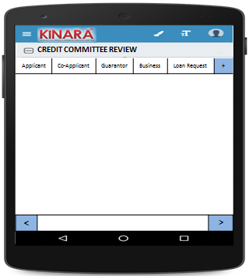

**4.2.1 Applicant**

Entity wise data display will start with Applicant

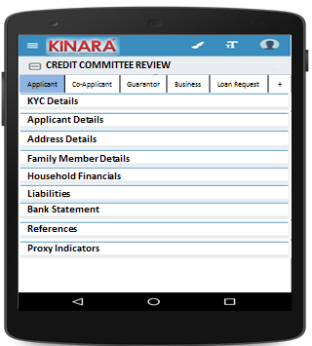

* + - 1. KYC Details:

All details will be auto-populated from field appraisal stage

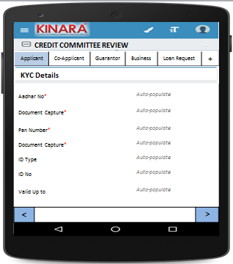

* + - 1. Applicant Details

All details will be auto-populated from field appraisal stage

|  |  |  |
| --- | --- | --- |
| Page 1 | Page 2 | Page 3 |

* + - 1. Address Details

All details will be auto-populated from field appraisal stage

|  |  |
| --- | --- |
| Page 1 | Page 2 |
| Page 3 | Page 4 |

* + - 1. Family Member Details

All details will be auto-populated from field appraisal stage

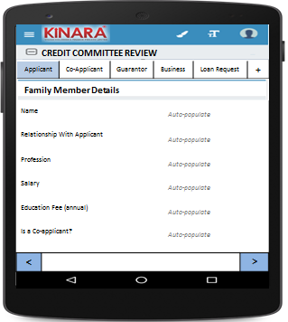

* + - 1. Household Financials

All details will be auto-populated from field appraisal stage

|  |  |
| --- | --- |
| Page 1 | Page 2 |

* + - 1. Liabilities

All details will be auto-populated from field appraisal stage

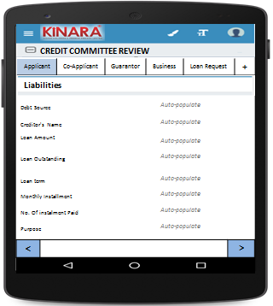

* + - 1. Bank Statement Details

All details will be auto-populated from field appraisal stage

|  |  |
| --- | --- |
| Page 1 | Page 2 |

* + - 1. References

All details will be auto-populated from field appraisal stage

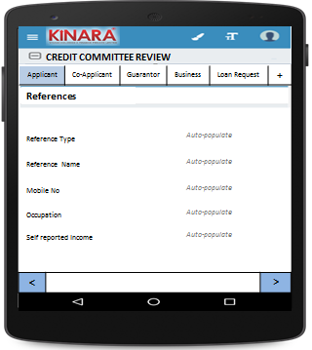

* + - 1. Proxy Indicators

|  |  |
| --- | --- |
| Page 1 | Page 2 |
| Page 3 | Page 4 |

* + 1. **Co-applicant**

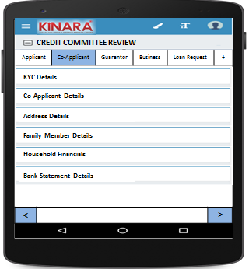

* + - 1. KYC Details

All details will be auto-populated from field appraisal stage

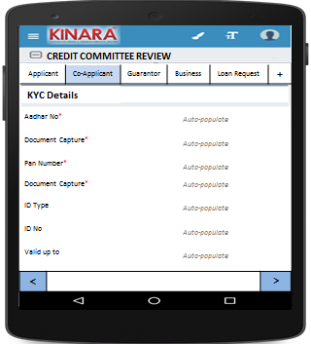

* + - 1. Co-applicant Details

All details will be auto-populated from field appraisal stage

|  |  |  |
| --- | --- | --- |
| Page 1 | Page 2 | Page 3 |

* + - 1. Address Details

All details will be auto-populated from field appraisal stage

|  |  |
| --- | --- |
| Page 1 | Page 2 |
| Page 3 | Page 4 |

* + - 1. Family Member Details

All details will be auto-populated from field appraisal stage

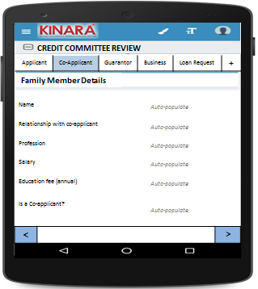

* + - 1. Household Financials  
         All details will be auto-populated from field appraisal stage

|  |  |
| --- | --- |
| Page 1 | Page 2 |

* + - 1. Bank Statement Details

All details will be auto-populated from field appraisal stage

|  |  |
| --- | --- |
| Page 1 | Page 2 |

* + 1. **Guarantor**

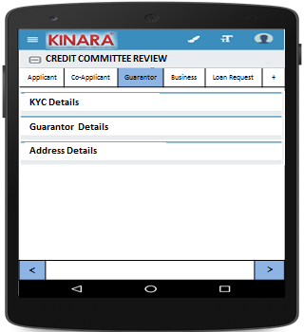

* + - 1. KYC Details

All details will be auto-populated from field appraisal stage

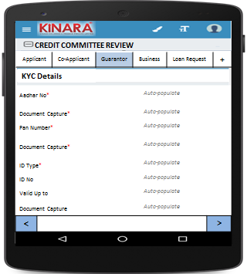

* + - 1. Guarantor Details

All details will be auto-populated from field appraisal stage

|  |  |  |
| --- | --- | --- |
| Page 1 | Page 2 | Page 3 |

* + - 1. Address Details

All details will be auto-populated from field appraisal stage

|  |  |
| --- | --- |
| Page 1 | Page 2 |
| Page 3 | Page 4 |

* + 1. **Business**

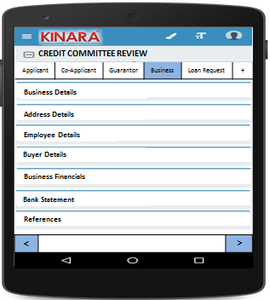

* + - 1. Business Details

All details will be auto-populated from field appraisal review stage

|  |  |  |
| --- | --- | --- |
| Page 1 | Page 2 | Page 3 |

* + - 1. Address Details

All details will be auto-populated from field appraisal stage

|  |  |
| --- | --- |
| Page 1 | Page 2 |

* + - 1. Employee Details

All details will be auto-populated from field appraisal stage

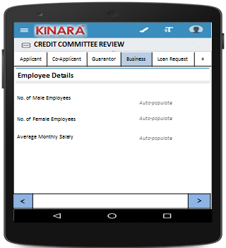

* + - 1. Buyer Details

All details will be auto-populated from field appraisal stage

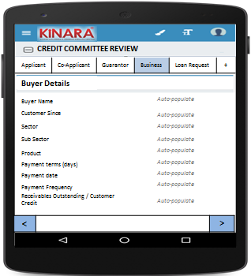

* + - 1. Business Financials

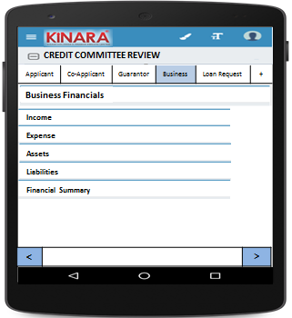

* + - * 1. Income

All details will be auto-populated from field appraisal review stage

|  |  |
| --- | --- |
| Page 1 – Through Sales | Page 2 – Other Business Income |

* + - * 1. Expense

All details will be auto-populated from field appraisal stage

|  |  |
| --- | --- |
| Page 1- Raw material expense | Page 2 – Salary and wages |
| Page 3 – Fixed Obligations | Page 4 – Other Expenses |

* + - * 1. Assets

All details will be auto-populated from field appraisal stage

|  |  |
| --- | --- |
| Page 1 – Current Assets | Page 2 – Inventory |
| Page 3 – Machinery (1) | Page 4 – Machinery(2) |
| Page 5 – Other Assets | |

* + - * 1. Liabilities

All details will be auto-populated from field appraisal stage

|  |  |
| --- | --- |
| Page 1 – Fixed | Page 2 – Current |

* + - * 1. Financial Summary

All details will be auto-populated from field appraisal stage

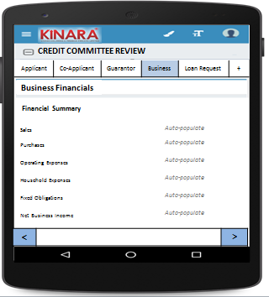

* + - 1. Bank Statement

All details will be auto-populated from field appraisal stage

|  |  |
| --- | --- |
| Page 1 | Page 2 |

* + - 1. References

All details will be auto-populated from field appraisal stage

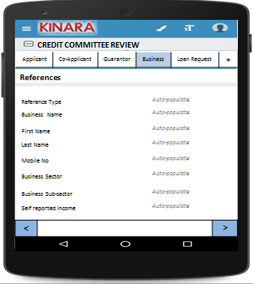

* + 1. **Loan Request**

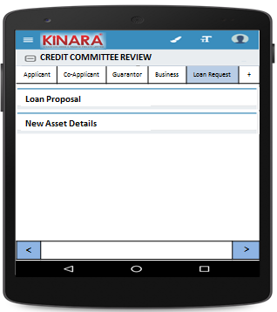

* + - 1. Loan Proposal

All details will be auto-populated from field appraisal stage

|  |  |
| --- | --- |
| Page 1 | Page 2 |

* + - 1. New Asset Details

All details will be auto-populated from field appraisal stage

|  |  |
| --- | --- |
| Page 1 | Page 2 |

* + 1. View Reference Check  
       All details will be auto-populated from field appraisal stage

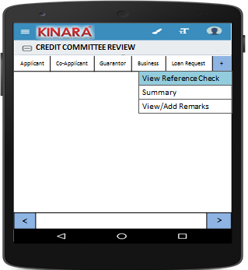

* + - 1. Reference Details

|  |  |
| --- | --- |
| Page 1 | Page 2 |
| Page 3 | Page 4 |

* + 1. Summary

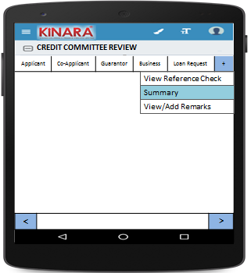

* + - 1. Ratios

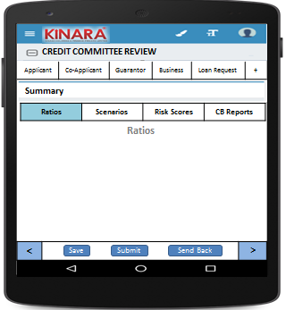

* + - 1. Scenarios

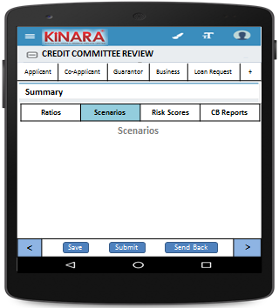

* + - 1. Risk Scores

|  |  |
| --- | --- |
| Page 1 | Page 2 |
| Page 3 | Page 4 |
| Page 5 | Page 6 |
| Page 7 | Page 8 |

* + - 1. CB Reports

|  |  |
| --- | --- |
| Page 1 | Page 2 |
| Page 3 | Page 4 |
| Page 5 | Page 6 |

* + 1. View/Add Remarks

|  |  |
| --- | --- |
| Page 1 | |
| Page 2 | Page 3 |

## Functional requirements

* 1. Once the profile is selected from the Credit Committee Review Queue, the member can view all the data captured and scores tabulated up to the field appraisal stage.
  2. CC Member will view all data and give remarks
  3. In case of any deviations, the CC member can send the loan back to any previous stage, or submit.
  4. On clicking ‘send back’ there should be option to choose which stage to send back to
  5. When Accepted the loan will automatically move to Loan Sanction queue
  6. When Rejected the loan application will sit in Rejected Application bucket

## Uploads

-NA-

## Downloads

-NA-

## Reports

-NA-

# Risk Score 3

## UI specification

## Screenshot

## Functional requirements

## Upload

## Download

## Reports